GREATER CAMBRIDGE LOCAL PLAN (GCLP) – FIRST PROPOSALS
REGULATION 18: PREFERRED OPTIONS
REPRESENTATIONS: K.B. Tebbit Ltd – LAND SOUTH WEST OF COMBERTON (SITE REF: 40152)

INTRODUCTION
- We act for KB Tebbit Ltd in respect of Land West of Comberton (Site Ref: 40152). The boundaries of the site are shown on the image below which offers the opportunity for a well-planned residential development to include significant areas of public open space, habitat creation and strategic landscaping.

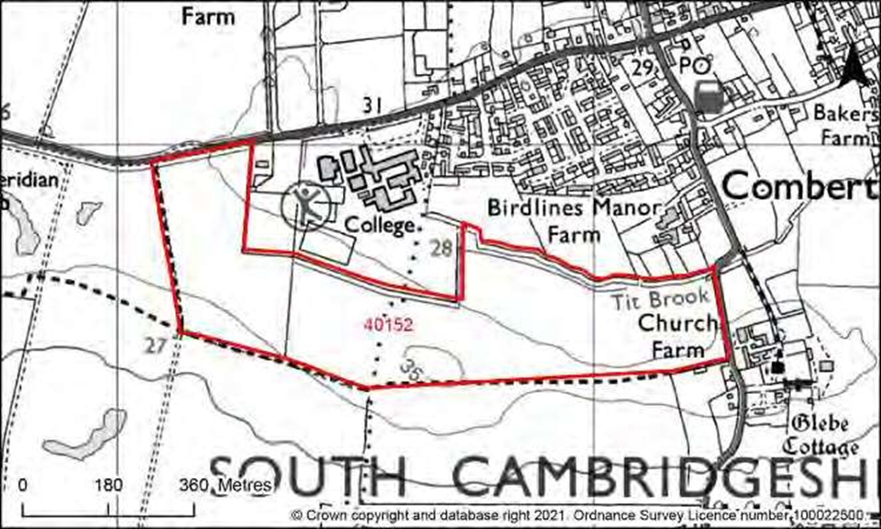

- On behalf of our client, we make the following representations on the Regulation 18 Preferred Options Consultation.

S/RRA: ALLOCATIONS IN THE REST OF THE RURAL AREA
- Our client is promoting land to the South West of Comberton (HELAA SITE REF: 40152) shown edged red on the plan above and we would welcome a discussion with the Local Planning Authority regarding the potential that the site offers in terms of a sustainable development that incorporates open space, environmental enhancement and landscape planting with a view to identifying the site as a Residential Allocation.
- We have analysed the local authorities HELAA review which appraises the development potential of the site. We have identified a number of errors/misinterpretations which we would like remedied as the preparation of the plan progresses. We have noted our comments against each issue as shown below in highlighted text:

Land to the south-west of Comberton CB23 7DU (Ref: 40152)

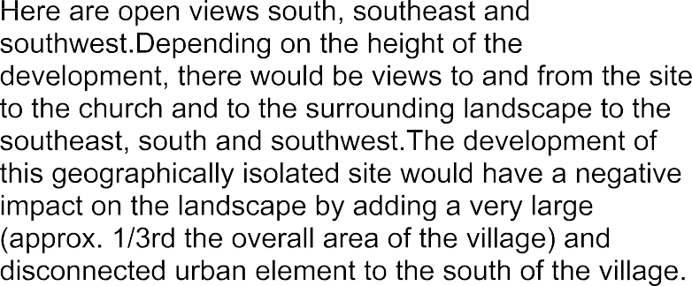

Comment – We accept that the boundaries represent a large potential development area however it is envisaged that a significant proportion of the site will be used for landscape improvements, public open space and habitat creation. The assessment should therefore be changed to Amber to reflect the opportunity for on-site mitigation.

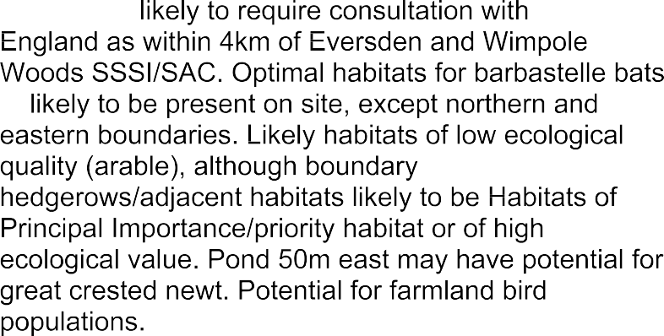

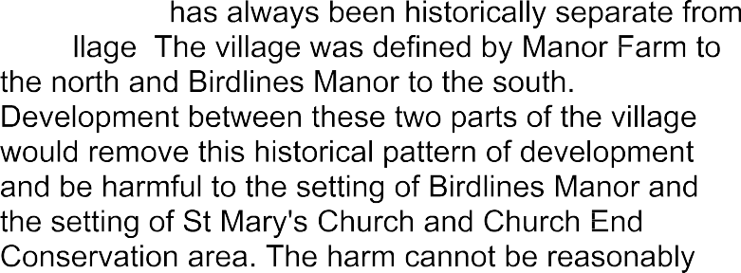

Comment – We recognize the concerns raised by the LPA in relation to development close to Church End and the impact on the settlement pattern and listed buildings. We envisage a significant area of open space in the vicinity of Church End which will maintain the settlement pattern and provide a buffer to protect the setting of the listed buildings. The open space will also offer recreational opportunities as well as habitat and landscape improvements. The potential for mitigation should be reflected in the scoring with a change in the assessment from Red to Amber.

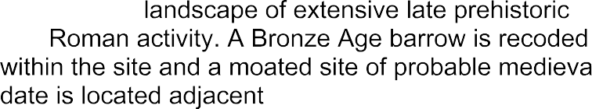

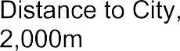

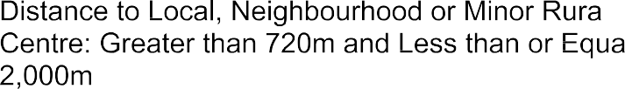

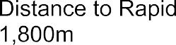

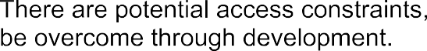

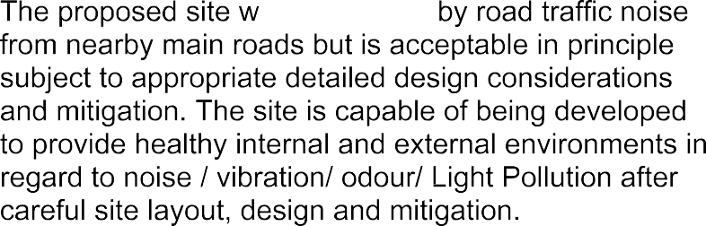

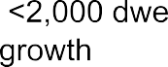

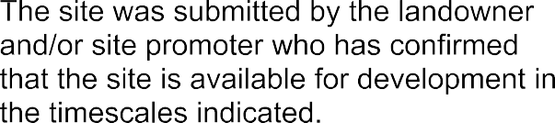

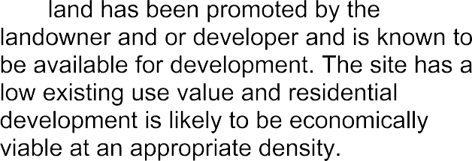

- As can be seen from the above the site scores well in the assessment and the two issues that have been given a red assessment can be adequately mitigated against and so the assessments should be adjusted from Red to Amber. This would then give the site an overall ‘Suitable Assessment’ of Amber.
- We also comment that the ‘Estimated Dwelling Units’ in the ‘Development Potential’ section should be changed to 300 to 600 units depending on the scale of development proposed.
- For the reasons highlighted in the representation we encourage the Local Planning Authority to amend the Development Strategy in the GCLP by including more allocations in rural settlements. Land to the South West of Comberton (Ref:40152) scores well in the HELAA review and should be identified as a residential allocation.

