- Sustainability Appraisal

  - The GCLP First Proposals Sustainability Appraisal (SA) was published in August 2021. The purpose of the SA is to promote sustainable development through integrating sustainability considerations into the preparation of plans. It is an integral part of good plan making and an ongoing process, involving continuing iterations to identify and report on the potential social, economic and environmental effects of the Local Plan.
The SA contains an assessment of the potential impact that site allocation options could have on a range of predefined social, economic and environmental objectives, set out during the SA scoping process. For the GCLP, the following objectives have been defined:
SA 1: Housing - To ensure that everyone has the opportunity to live in a decent, well-designed, sustainably constructed and affordable home.
SA 2: Access to services and facilities - To maintain and improve access to centres of services and facilities including health centres and education.
SA 3: Social inclusion and Equalities - To encourage social inclusion, strengthen community cohesion, and advance equality between those who share a protected characteristic (Equality Act 2010) and those who do not.
SA 4: Health - To improve public health, safety and wellbeing and reduce health inequalities.
SA 5: Biodiversity and geodiversity - To conserve, enhance, restore and connect wildlife, habitats, species and/or sites of biodiversity or geological interest.
SA 6: Landscape and townscape - To conserve and enhance the character and distinctiveness of Greater Cambridge’s landscapes and townscapes, maintaining and strengthening local distinctiveness and sense of place.
SA 7: Historic environment - To conserve and/or enhance the qualities, fabric, setting and accessibility of Greater Cambridge’s historic environment.
SA 8: Efficient use of land - To make efficient use of Greater Cambridge’s land resources through the re-use of previously developed land and conserve its soils.
SA 9: Minerals - To conserve mineral resources in Greater Cambridge
SA 10: Water - To achieve sustainable water resource management and enhance the quality of Greater Cambridge’s waters.
SA 11: Adaptation to climate change - To adapt to climate change including minimising flood risk.
SA 12: Climate change mitigation - To minimise Greater Cambridge’s contribution to climate change
SA 13: Air quality - To limit air pollution in Greater Cambridge and ensure lasting improvements in air quality.
SA 14: Economy - To facilitate a sustainable and growing economy.
SA 15: Employment - To deliver, maintain and enhance access to diverse employment opportunities, to meet both current and future needs in Greater Cambridge.

  - The SA contains an appraisal of the various spatial options proposed for the Local Plan, with detailed analysis provided at the Strategic Spatial Options level and at a site level.
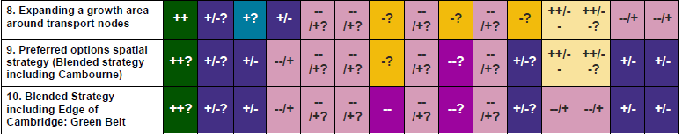
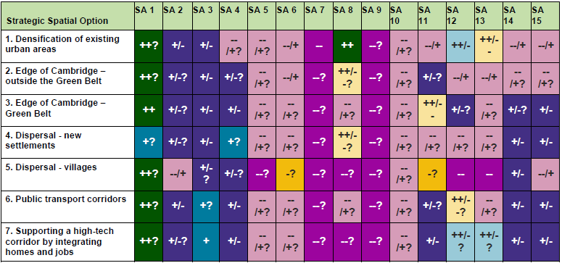
  - The Land north of Cambourne is included within the ‘Growth around transport nodes’ Strategic Spatial Option (Option 8), and the SA finds that this option performs at least as well as, if not better than, the other Strategic Spatial Options for the listed SA objectives.

Table 5.1 : SA Non-Technical Summary Table 3: Summary of SA effects for Strategic Spatial Options 2020-2041

  - Key issues here relate to SA 14 (Economy) and SA 15 (Employment). As discussed above, the provision of extensive employment space and supporting community facilities will provide benefits for both these objectives, as well as linking residents of Cambourne with employment opportunities elsewhere in the district following the implementation of EWR and C2C.
  - Adaptation to climate change (SA 11)., specifically flood risk, is also highlighted as an issue with a negative impact. However, as stated above, the Land north of Cambourne is within Flood Zone 1, and is therefore at a low risk of flooding. Although some isolated pockets of surface water flood risk exist on site, which can be mitigated effectively through SuDS interventions incorporated within the public open spaces.
  - At a more detailed level, the comparison of the SA objectives is provided for each site within the Strategic Spatial Option. The table below is reproduced from the SA:

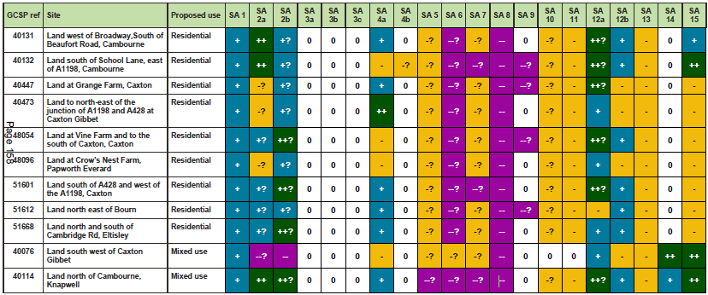
Table 5.2: Table 4.22: Summary of SA findings for the Growth around transport nodes: Cambourne Area site options
  - A comparison of the sites presented above, indicates that the Land north of Cambourne performs better than any of the other sites, when SA objectives are combined, with the Site performing at the highest level in relation to other sites for:
SA 2 (Access to services and facilities)
SA 12 (Climate change mitigation)
SA 15 (Employment)

  - The objectives for which the Site is marked with a negative impact compared with other sites include
SA 5 (Biodiversity and geodiversity)
SA 6 (Landscape and townscape)
SA 7 (Historic environment)

  - Following the publication of the SA, a number of additional studies have been carried out to demonstrate that the impacts referred to above can be mitigated through good design and urban planning. The illustrative masterplan for the Site has therefore been updated to account for this most recent information as well as relevant mitigation measures.
  - A summary of the relevant impact and mitigation studies is provided below, with additional information provided in accompanying technical reports.

Biodiversity and geodiversity
  - North Cambourne contains the Elsworth Wood SSSI, the Knapwell Wood ancient woodland, and is adjacent to the Brockley End Meadow County Wildlife Site. It also contains areas of deciduous woodland which have been classed as priority woodland, along with ditches, watercourses, grasslands, hedges and wooded boundaries that are also likely to have ecological value.
  - The illustrative masterplan contained in the vision document shows how the features identified as being of greatest ecological value will be retained. These features will be protected and enhanced during the construction and operation of phases of the proposal, with suitable measures employed to ensure relevant species and habitats are protected in accordance with relevant Natural England guidance pertaining to SSSIs.
  - The guidance for the Elsworth Wood SSSI and the associated Impact Risk Zone states that, ‘New housing developments will require an assessment of recreational pressure on relevant SSSIs and measures to mitigate adverse impacts.’
  - As shown in the illustrative masterplan, considerable areas of North Cambourne will be dedicated to recreational open space, with approximately two-thirds of the site area retained as open space. This level of provision will ensure that there will be no additional recreational pressure placed on the SSSI. In addition, no built development is proposed within 250m of the SSSI, providing ample buffer space to mitigate potential impacts during construction and operation.
  - To ensure the protection of the most sensitive habitats, the illustrative masterplan shows considerable buffer zones around other ecological sites of interest. The Forestry Commission and Natural England recommend a 15m buffer zone around woodlands to avoid root damage during development. The masterplan has been developed to provide a 25m buffer zone around the woodland, exceeding recommended distances and further mitigating impacts.
  - In addition, the scale of the site is such that there is sufficient land available to accommodate significant new planting and thereby enhance woodland coverage. Furthermore, the masterplan shows an integrated green infrastructure network that will link key areas of woodland habitat, including Elsworth Wood, Knapwell Wood, Honeyhill Wood and New Wood.
  - In addition to providing added amenity, habitat and biodiversity value, the extent of tree planting will also deliver carbon sequestration benefits. Furthermore, any hedgerow loss or alteration to existing hedgerows will be compensated for by new hedgerow planting.
  - In addition to Green Infrastructure, significant areas of North Cambourne will be dedicated to enhance the provision of blue infrastructure. The addition of extensive water bodies will increase the diversity and ecological capacity of the area as well as provide for the management of surface water as part of a site-wide SuDS strategy.
Landscape and Townscape

  - Additional analysis has been undertaken to assess the landscape effects of development on the land at North Cambourne (a full Landscape Assessment report, prepared by Cooper Landscape Planning is provided as an accompanying technical report). The report updates a previous study undertaken in 2020 with the revised illustrative layout provided as an Appendix. The extent of potential development shown in previous proposals has been reduced in response to this landscape-led approach to design. This approach makes use of the screening effect afforded by:
woodland areas within and on the edge of the site;
the extensive local hedgerow network; and
the plateau effect of the landform and the gentle north- south valleys.

  - A series of photomontages have been developed to demonstrate that the proposed illustrative masterplan will not have a significant detrimental impact on the landscape, and particularly that the area of development will not produce unacceptable visual effects when seen from local villages including Elsworth and Knapwell.
  - Other key conclusions from this analysis are consistent with the findings of the 2020 study and demonstrate that North Cambourne is largely inconspicuous in views from the surrounding landscape. This is in part due to the flat nature of the topography adjoining the northern boundary of the Site, such that visibility is readily curtailed by intervening features such as hedgerows, woodland and trees. Another factor contributing to the lack of views is the scarcity of publicly accessible viewpoints from roads and other public rights of way within the surrounding landscape and with very few elevated viewpoints in the area.
  - Importantly, the scale of the site provides for the creation of a distinctive sense of place for new development, which respects the existing landscape characteristics as well as accommodating new woodland and hedgerows.
  - The creation of green corridors along a series of small-scale valleys and associated watercourses enhance the existing landscape character of the Western Claylands is in keeping with the Cambridgeshire Landscape Guidelines.
  - The landscape and visual appraisal demonstrates that there are potential effects that would be caused by new development at North Cambourne, but that these potential effects can be successfully addressed by a landscape-led approach to design, which respects key landscape characteristics and views.
  - The illustrative masterplan demonstrates how a design approach based on strong green corridors, open spaces, retention and enhancement of woodland and respect for views can high quality new community.
Historic Environment

  - As stated above in Section 3, the presence of a listed building and existence of archaeological crop marks give rise to potential for adverse effects on historic assets. In order to assess this impact and set out potential mitigation measures in more detail, an additional assessment of heritage features on the site has been carried out by Savills Heritage, included as an accompanying technical report.
  - The summary provided in Section 3 states that the known heritage assets sensitive to any development within the site includes the two Grade II listed structures at New Inn Farm, and potentially non-designated heritage assets at other historic farmsteads within, and immediately adjacent to, the site.
  - In light of the presence of these historic features, a series of measures is proposed to mitigate any adverse effects, including
locating certain types of development/open space appropriately to preserve archaeology in situ;
undertaking a staged programme of archaeological fieldwork, including a Desk-Based Assessment and / or geophysical surveying to focused evaluation trenching by way of an agreed Written Scheme of Investigation. The results of this additional assessment could further inform the level of significance of these remains and any further mitigation that may be necessary; and
a sensitively designed layout, which includes off-setting development and/or the appropriate use of intervening landscaping to help mitigate potentially adverse harm to the setting of the designated and non-designated heritage assets within or adjacent to the site. Notably, this includes there is no built development adjacent to the listed New Inn Farmhouse and barns in order to preserve their setting and minimise impact.

These measures reduce the risk of adverse impact on the historic environment. It should, however, be noted that none of the sites under consideration for the Cambourne Area are considered to be free of risk to the historic environment, and that all would require mitigation in some form, similar to that described above.

Summary
  - As a result of the additional design assessment and mitigation analysis set out above and in the accompanying technical reports, a comprehensive mitigation strategy has been devised to avoid negative impacts on the key characteristics of the site highlighted in the SA, including biodiversity and geodiversity, landscape and townscape, and the historic environment.
  - Additional documentation has also been provided as part of the SA evidence base, including the supplement to Appendix E of the SA, ‘Councils’ justification for selecting sites to take forward for allocation and discounting alternatives’. Within this part of the SA, a summary is provided of why sites subject to appraisal were included in the First Proposals as preferred options, and why other sites were not included.
  - The land at North Cambourne is included in this report, with the following narrative, ‘The preferred development strategy identifies Cambourne as a broad location for future development, in association with the opportunities provided by East West Rail and in particular the proposed new railway station. The location of the station has not yet been established and will be key to understanding where and how additional development should be planned, including considering the individual site constraints identified when testing these land parcels which were put forward through the call for sites process. The allocation of a specific area or quantity of growth has therefore been rejected.’
  - The SA and resulting narrative does not include any reference to the SA objectives referred to above, choosing to focus on the uncertain delivery of the North Cambourne station as part of East West Rail. Nevertheless, the site scores positively in relation to criterion SA 12 (Climate change mitigation) in the SA scoring matrix (as shown above). The reasoning in the SA and the consequent rejection of the site is therefore at odds with other elements in the SA findings.
  - Notwithstanding the SA, greater certainty has more recently been provided on the location of the new railway station for East West Rail with the publication of ‘Making Meaningful Connections’ Consultation Document published in March 2021. This consultation document shows the preferred option for a station at Cambourne to the north of the A428. This recent commitment further underpins the suitability of the North Cambourne proposal as a highly sustainable location for a new mixed-use community and overrides the reason for rejection of the site in the site-specific SA process.
  - MGH therefore request that the North Cambourne proposal is confirmed in future drafts of the GCLP and that the information submitted with these representations is taken into account to amend the evidence base for the GCLP in support of the allocation.

