Dear Sir,

I write to offer the view of residents of Babraham Village on the submission of:
- The Babraham Research Campus, Cambridge, CB22 3AT Site Reference: 51604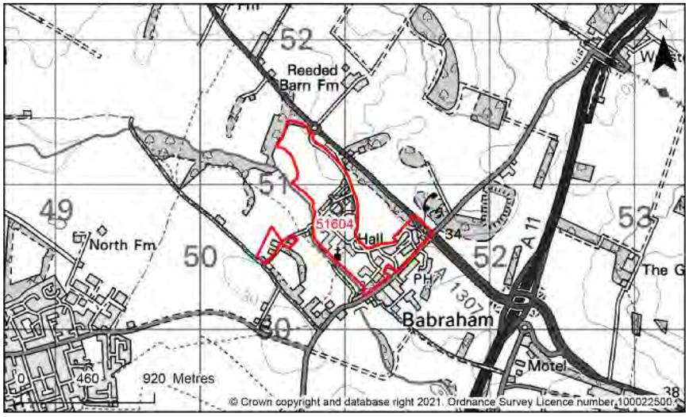
- Land adjacent to Babraham, CB22 3AF, CB22 3AP, CB22 3AG, CB22 3AZ Site Reference: 40297
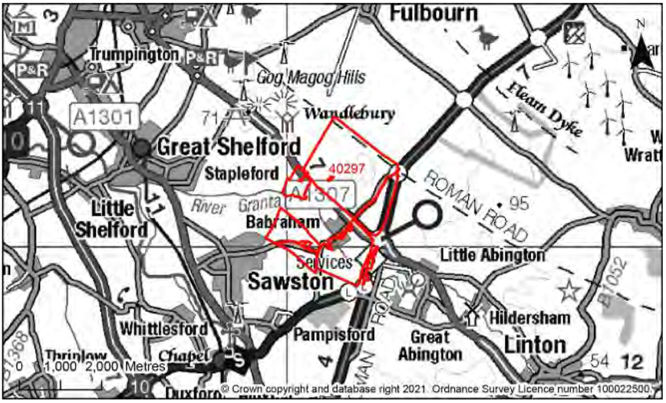

- Land to the south of Babraham Road and east of site H1c, Sawston, CB22 3JH, Site Reference: 40509
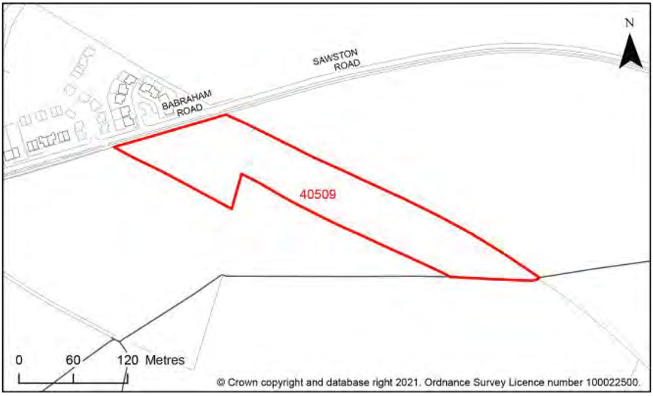

Land submitted for planning permission within Babraham Parish
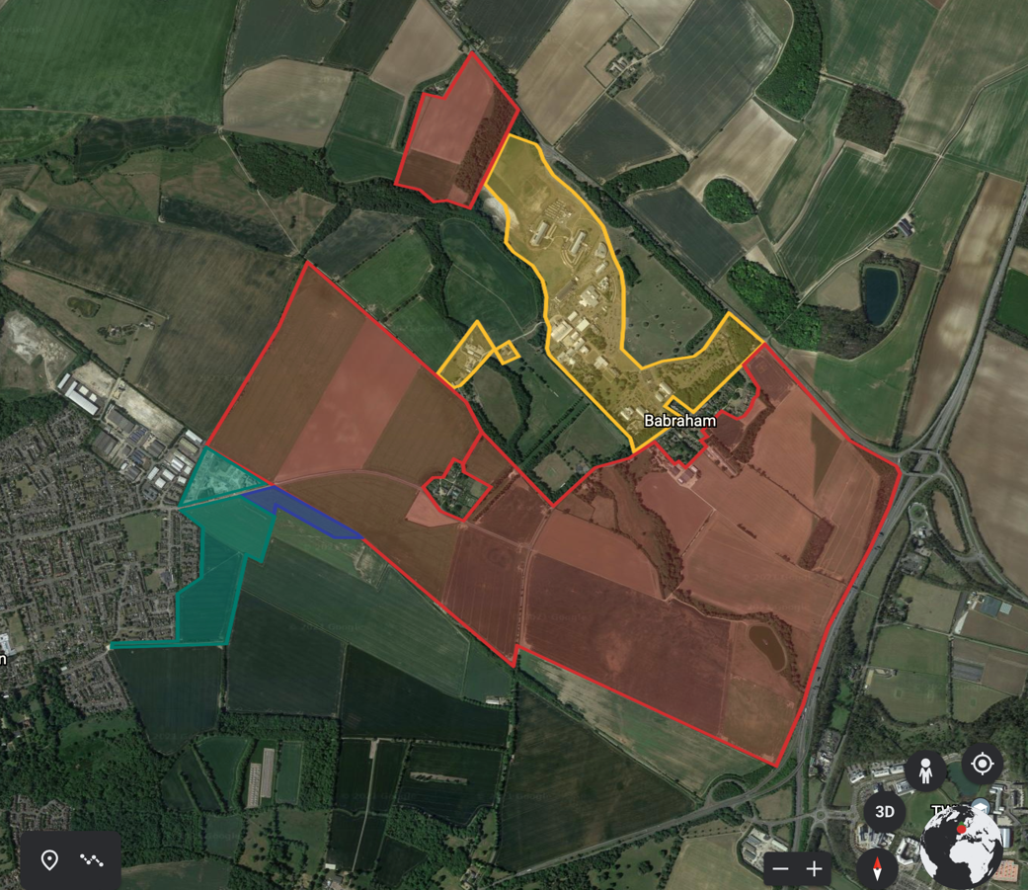
Yellow: 51604 – removal of and from greenbelt and use for research and development
Red: 40297 – proposed building of 3500 houses
Blue: 40509 – Proposed building of 70 houses
Green: land within Babraham Parish already give planning permission for 360 new houses

It is the view of the signatories, all of whom live in Babraham village, that these proposals will have a significant adverse impact on Babraham village character, its surrounding environment, local wildlife habitat and historic interest.

History of Babraham
Babraham was prosperous in the Middle Ages. Domesday records record 38 tenants in 1086, with a flock of 205 sheep and a watermill. In the late 16th Century there were about 10 ‘substantial landholders’ in Babraham but from 1576 Robert Taylor bought up these properties, beginning a process by which the wealth of the Parish eventually became concentrated in the hands of one landowner. In 1632 the manor and nearly all the land in Babraham was acquired by the Bennet family. They sold the estate to Robert Jones in 1770, and in due course it was inherited by the Adeane family.

The Bennet’s and the Adeane’s dominated every aspect of parish life between the 17th and 19th Centuries. The consolidation of their landholdings made possible agricultural improvements that required large capital investment, such as the diversion of the river to irrigate the meadows east of the village, which was undertaken by Thomas Bennet in the 1650s at a cost of £10,000 (figure 1 and 2).

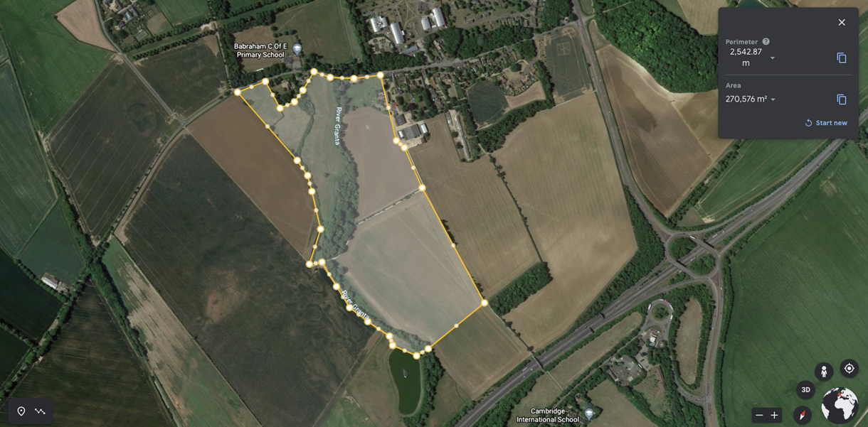
Figure 1 location of the ancient water meadow to the South of Babraham village.

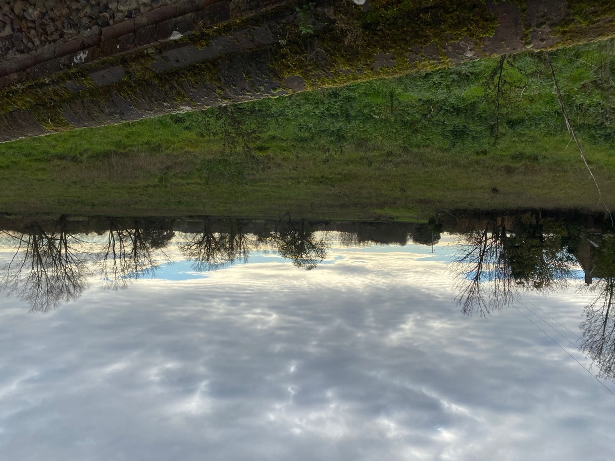
Figure 2, looking out from Babraham High Street across the ancient water meadow, a vital open space in the middle of the village

In 1823 Henry John Adeane inherited the estate and commissioned Philip Hardwick to design a new house: the neo-Jacobean Babraham Hall was built between 1832 and 1837 and enlarged in 1864. The gardens were laid out in the same year, reconstructing an earlier layout shown on a sixteenth-century plan. The Avenue may have been planted at this time; it is not shown on the tithe map of 1851 (figure 3) but is present on the earliest available OS map, of 1881 (figure 4). The open aspect in which the avenue is enjoyed is seen in figure 5.

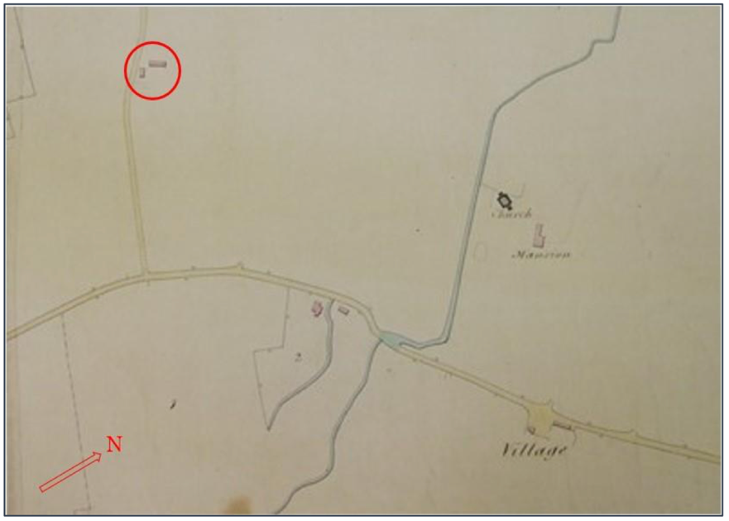

Figure 3. Tithe Map of 1851 showing 3 of 13 listed buildings in Babraham including Babraham Hall (Mansion) (Grade 2) St Peter’s Church (Grade 1) and Church Farm House (Grade 2)
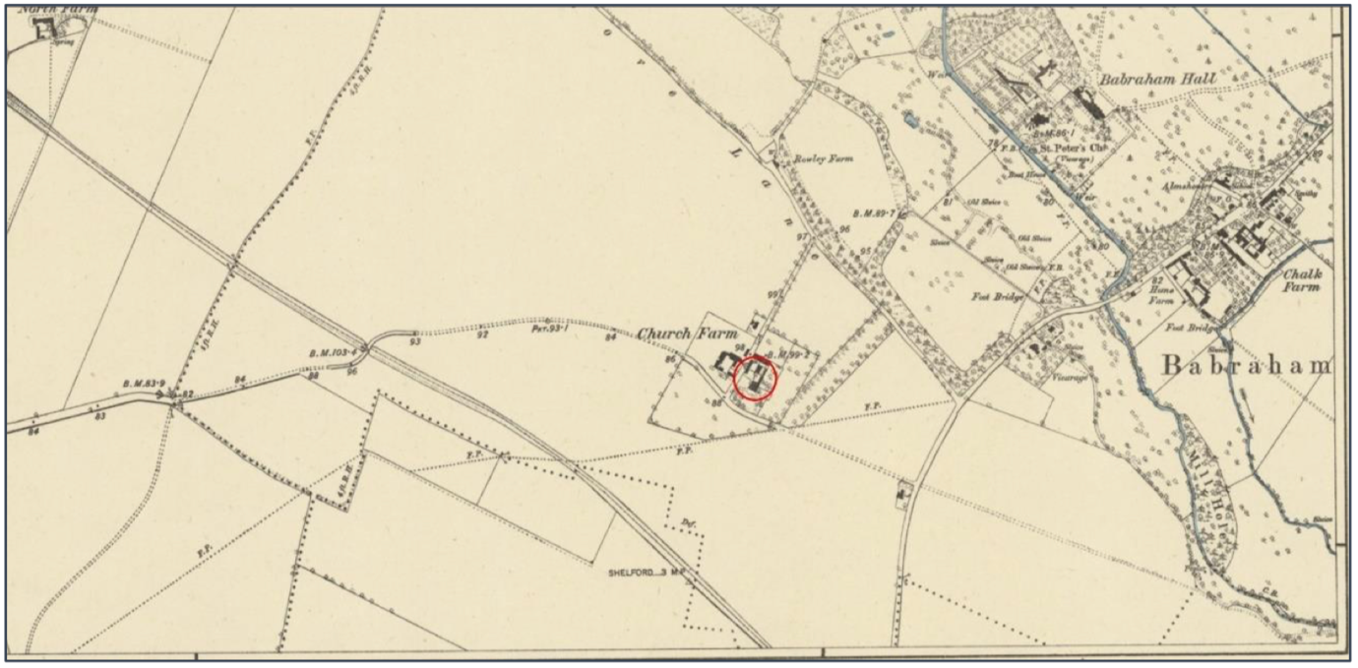
Figure 4. OS Map 1885 showing the newly planted avenue of trees (arrow) running from Babraham Hall to the right of Church Farm House owned by the tenant farmer Jonas Webb (circled).

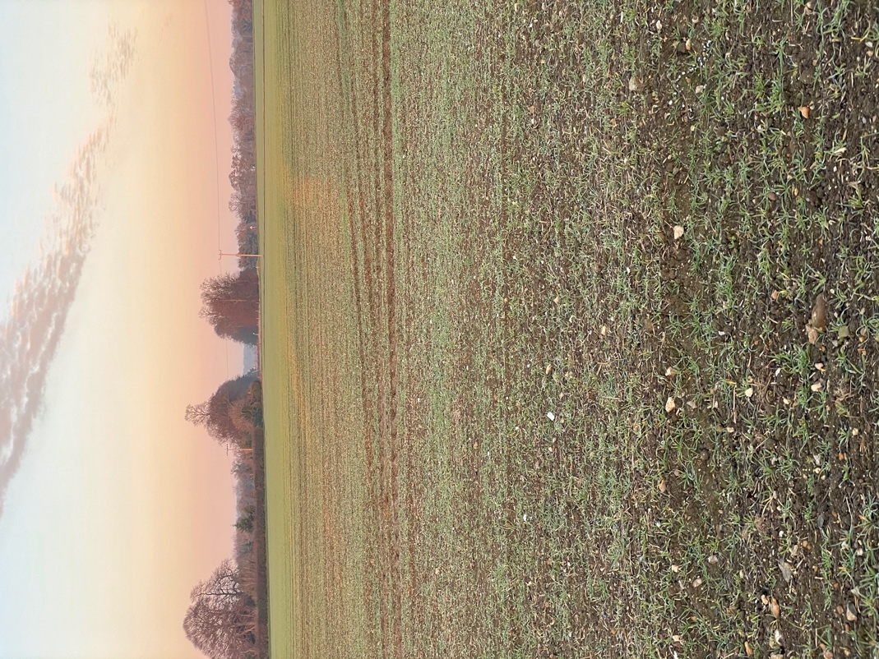
Figure 5. Looking across open farmland down the avenue of trees leading, in the distance, to Babraham Hall. All this land has been submitted for housing development.

In 1948 Babraham Hall and 182 hectares of farm and woodland in the Babraham Estate were sold to the Agricultural Research Council (ARC) and became the Institute of Animal Physiology. This is now the Babraham Research Campus, and several new laboratories and administrative buildings have been built in the grounds. These buildings run adjacent and overlook the historic walled gardens as well as the Grade 1 listed St Peter’s Church.

The population of Babraham
The population of Babraham peaked at 304 in 1861. It declined during the first half of the
twentieth century, falling to 226 in 1951. It once again increased to 327 in 1971 reflecting the development of new housing in The Close to accommodate the staff of the Babraham Research Institute. the 2011 Census recorded 276 people in the village and 130 households.

Agriculture in Babraham
Improved farming methods at Babraham were encouraged by H. J. Adeane, lord of the manor 1823–47. By 1825 a four-course rotation was stipulated for Adeane's tenants. The principal crops in the 19th Century were wheat and barley, with large quantities of turnips grown for feed. Threequarters of the land in the Parish (1,751 acres) was under crops in 1845. The remaining land was devoted to sheep pasture. In 1794 there were about 1,000 sheep in the parish; by 1845 there were 419 acres under pasture; by 1905 this had increased to 553 acres. (Victoria County House 1973). This enlargement of the pasture was due to the success of the Adeane’s tenant, Jonas Webb (figure 6), in raising a flock of prize-winning sheep at Babraham.

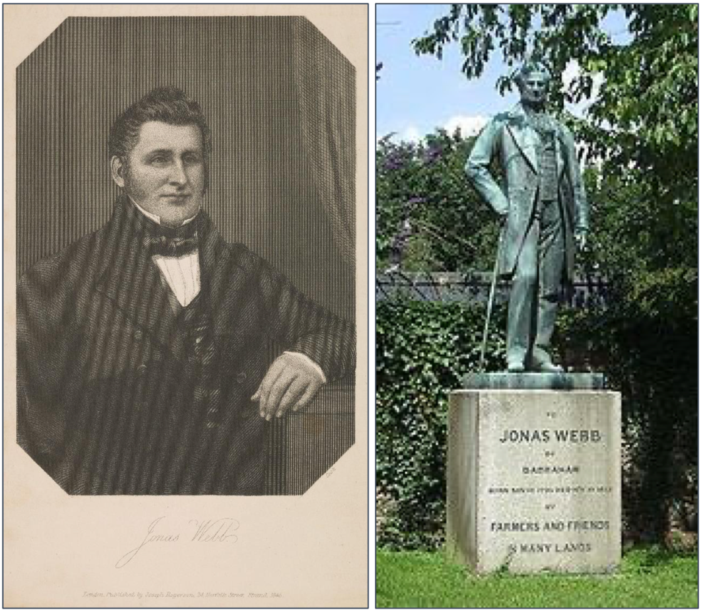
Figure 6. Jonas Webb (left), unknown artist, 1846 (NGS). Fig 4 (right) Statue of Jonas Webb, Babraham High Street, by Baron Carlo Marochetti, after 1862

Records suggest that Jonas and his brother Samuel were employed to oversee the enclosure of common land on the Adeane Estate. This was completed in 1820, and Jonas, then aged 23, was rewarded with the tenancy of the old Church Farm, adjacent to the parish church.

In 1844, Jonas Webb moved to Church Farm House, where he remained until his death in 1862. He brought in Southdown sheep from Sussex breeders, built up his flock to 2,400 sheep, and by selective breeding and careful husbandry increased the meat yielded by each animal. He exhibited his animals at all the major agricultural shows, where they won many prizes. He is commemorated in Babraham High Street with a statue by Baron Carlo Marochetti (1805–67), one of Queen Victoria’s favourite sculptors, representing him as ‘an epitome of mid-Victorian prosperity’. (Bradley & Pevsner 2014; 427)

The setting of Babraham village, Babraham Hall and surrounding listed buildings
Babraham village is dominated by Babraham Hall and has indeed been moulded by the decisions taken by the owners and their interest in farming methods. Firstly, the diversion of the River Granta and creation of the water meadow in the 17th Century. The subsequent enclosures and creation of a number of farms laid mainly to crops and meadow in the 19th Century. The early animal husbandry pioneered by Jonas Webb leading to further land put to pasture.

The village has remained largely unchanged, which is supported by the unusually high proportion of listed buildings in the village and around the Parish. The proposals put forward for 3570 houses around the village and removal of large parts of the Parish from green belt for expansion of the Research and Development site would destroy the environment within which the village sits (figure 7).

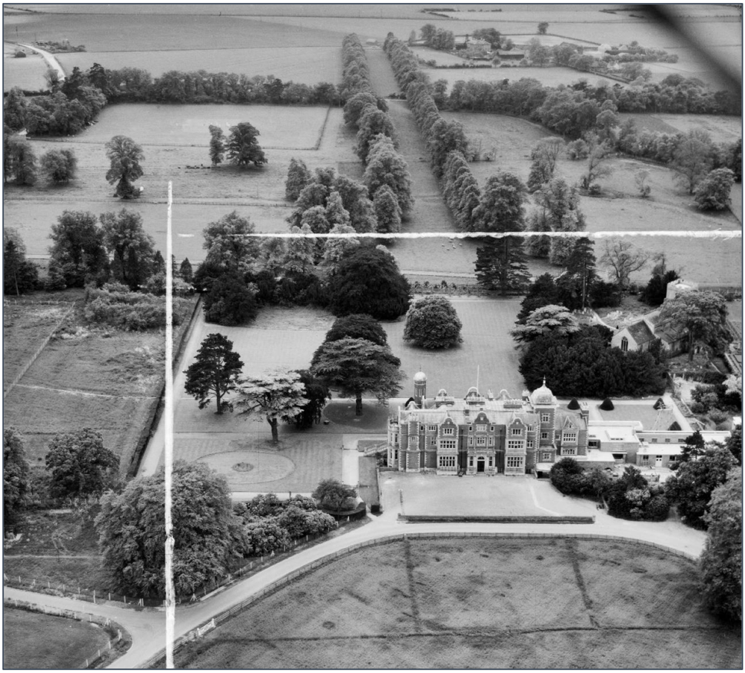
Figure 6. An aerial photograph taken in 1953. It shows how the Avenue of trees connecting the formal gardens of the Hall to the farmland south of Sawston Road. The wider setting of Babraham Hall and the Parish Church of St Peter. Both are listed buildings; the Grade I listing of the church indicates that it is of exceptional interest: just 2.5% of listed buildings are Grade I. The church sits within the Babraham Hall estate and the avenue of trees creates a physical, visual and historic connection to the farmland location.

The open rolling chalk farmland consists of flat large fields intersected by roads and footpaths, with some low hedge boundaries. This provides a typical East Anglian farmland setting in which Babraham and its surrounding historic buildings are set. Of special interest are the isolated clusters of buildings dotted around the Parish reflecting the historic creation of individual tenant farms during the enclosures. Sawston Road and High Street are historic routes; together with the footpath to Sawston they provide ample opportunities to appreciate this historic farmland setting. The landscape is so flat and open that these routes provide views of all the types. Building houses over this landscape would destroy this aspect.

The designed progression from Babraham Hall through formal gardens and the canalised River Granta to parkland with trees and thence to open treeless fields contributes to our understanding of the Hall as the centre of the Adeane Estate. The open farmland setting contributes to our understanding of Church Farm as the centre of a historically important sheep-farming operation. For these reasons, the undeveloped open character of the farmland setting makes a significant contribution to the significance of the heritage assets.

Conclusion
Babraham village is set in open farmland created over centuries by successive landowners to become one of a very few Cambridgeshire villages that remain largely untouched. The ancient water meadow, River Granta flood plain, parkland setting, and wider agricultural landscape would be destroyed by the proposals submitted by the current landowners.

