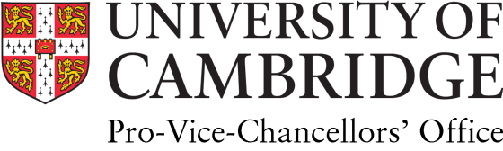 | Professor Graham Virgo QC (Hon) MA BCL  Senior Pro-Vice-Chancellor (Education)  Professor of English Private Law

7th December 2021

I write in my capacity as Senior Pro-Vice-Chancellor in the University of Cambridge to acknowledge the unreserved support of the University of Cambridge for the Cambridge Mathematics School and the need to identify a permanent site for the school.

The Cambridge Mathematics School is a new specialist sixth form being which is developed in partnership with the University of Cambridge. It will open in September 2023 with a focus on pioneering learning and increasing diversity in the field of maths. Temporarily based in Mill Road until a permanent site is identified, the School will welcome 16 to 19-year-old A-Level students from across the East of England, and aims to attract more female students into maths subjects, more students from minority ethnic groups, and more students from socially and educationally disadvantaged backgrounds.

The Eastern Learning Alliance (ELA) - a multi-academy trust with schools across Cambridgeshire and East Anglia – will run the Cambridge Mathematics School, in collaboration with the University of Cambridge. It will offer A-Level maths, further maths, physics, chemistry, biology and computer science, and join a nationwide network of maths schools, one for every region of England, announced by the government.

The principal aim of maths schools is to help prepare more of the UK’s most mathematically able students to succeed in maths disciplines at top universities, and address the UK’s skills shortage in science, technology, engineering and maths (STEM) subjects.

The School will draw on the University’s Widening Participation and outreach experience, in particular the success of The Millennium Mathematics Project (MMP) and its NRICH programme, which provides free online mathematics resources for ages 3 to 18 - completely free and available to all. The University and Cambridge colleges will work together with the ELA on the project, and materials and learning created through the partnership would be shared with other schools to benefit students across the UK.

Graham Virgo

